**STUDENT NUMBER: ST10475262**

**NAME: Boikanyo Dimpho**

**MODULE NAME: WEB DEVELOPMENT**

**MODULE CODE: WEDE5020**

**WEBSITE PROPOSAL**

**Sweet Delights Bakery**

Founded in 2022 by pastry chef Maria Rodriguez, Sweet Delights Bakery specializes in handcrafted, small-batch desserts made with premium ingredients. The bakery offers custom cakes, gourmet cookies, artisanal bread, and seasonal pastries, all baked fresh daily.

The **Mission Statement** for the website:

* To create unforgettable desserts with love, quality, and creativity.

The **Vision Statement** for the bakery is:

* To be the most trusted local bakery for custom celebrations and everyday indulgence.

The **Target Audience** for Sweet Delights Bakery would be:

* Families (birthdays, weddings, celebrations).
* Cafés & small businesses (wholesale orders).
* Health-conscious consumers (offering gluten-free & vegan options).

**Website Goals and Objectives:**

* **Primary Goal:** Increase online orders by 50% within six months.
* **Secondary Goals:**
  + Showcase the bakery’s portfolio with high-quality images.
  + Streamline custom order bookings via an online form.

**Current Website Analysis:**

Sweet Delights Bakery is a new business and it does not have an online presence. It mainly relies on loyal customers and word of mouth for advertisements. There are several disadvantages that come with not having a website. These **disadvantages** include:

**Poor Visibility and Discoverability:**

The vast majority of customers turn to Google Search and Google Maps to find products, services, and business information. Without a website, you are virtually invisible in these critical search results, missing out on your most valuable source of new, intent-driven customers.

**Missed Sales and Conversion Opportunities:**

A website acts as your 24/7 salesperson. It's always open, providing information, generating leads, and processing sales. Without it, you miss out on business from customers researching after hours or when you're not available to respond on social media.

The **advantages** that come with having a website are:

**Superior Functionality:**

A website can seamlessly integrate critical functions like e-commerce stores, booking systems, detailed service pages, email list sign-ups, and blogs—things social media profiles cannot fully replicate.

**Control & Ownership:**

Your website is a digital asset you own. You control the design, content, user experience, and are not subject to sudden algorithm changes or platform rules that can disrupt your business.

**Proposed Website Features & Functionality:**

* **Homepage:** Featured seasonal products and promotions.
* **Gallery:** High-resolution images of cakes, pastries, and bread.
* **About us:** About the website and owner
* **Custom Order:** Drop-down selections for flavours, sizes, and dietary preferences.
* **Contact us:** Get in contact with the owner about enquiries.
* **Blog:** "Baking Tips" and behind-the-scenes content.

**Design & User Experience:**

* **Colour Scheme:** Warm pastels (cream, soft pink, gold accents).
* **Typography:** Elegant serif (Cormorant Garamond) for headings, clean sans-serif (Lato) for readability.
* **Layout:** Clean, inviting, with clear call-to-action buttons ("Order Now").

**Technical Requirements:**

* **Hosting:** Squarespace (for ease of use and built-in e-commerce).
* **Domain:** [www.sweetdelightsbakery.com](http://www.sweetdelightsbakery.com)
* **Languages:** HTML/CSS (Squarespace templates), minimal JavaScript for animations.

**Timeline & Milestones:**

WEEK 1: Research and planning

WEEK 2 - WEEK 3: Wireframe and drafting content

WEEK 3 - WEEK 4: Creating the homepage, contact page and about us page

WEEK 5 - WEEK 6: Adding CSS elements and elements to the pages

WEEK 7: Adding Java animations and fixing any bugs

WEEK 8: Final testing and deployment

**Budget:**

* **Domain & Hosting:** R340 /year.
* **Photography:**  R500 (professional product shots).
* **Marketing:** R600 (Facebook/Instagram ads).

**Website sitemap:**

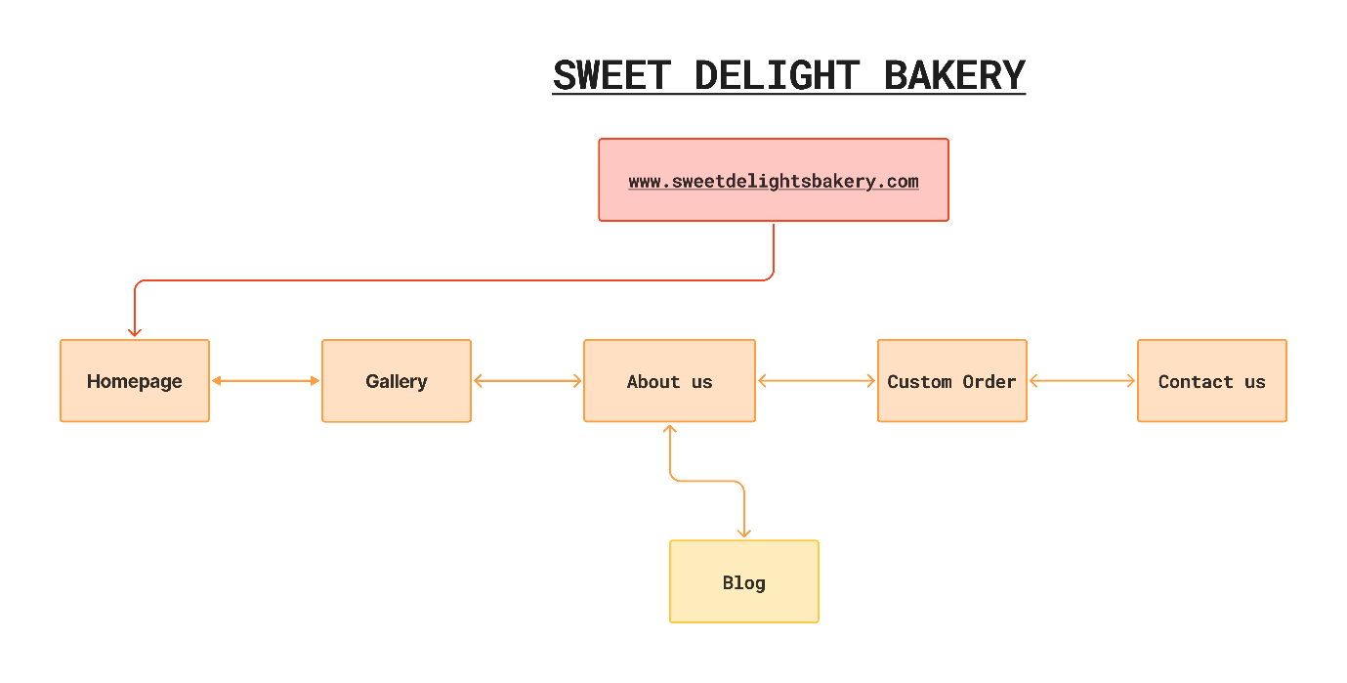

**References:**

Host Africa, “Domains.” *HOSTAFRICA*, Aug. 2022, <https://hostafrica.co.za/domains/>

Host Africa, “Web Hosting.” *HOSTAFRICA*, Aug. 2022, <https://hostafrica.co.za/web-hosting/>